Page Layout
Page layout in CSS refers to how elements are structured, positioned, and arranged on a web page using CSS properties.
Example 1: Positioning of Div
<div class="w-fit mx-auto bg-yellow-50 p-4">
<div class="p-4 bg-red-200">Check Padding</div>
</div>
Inner Div has content “Check Padding” which is fit by the parent container by w-fit
mx-auto centered the parent div
Example 2: Table with fixed cells using div elements
<h2 class="text-2xl font-bold mb-4 text-center">Table with fixed columns</h2>
<div class="grid grid-cols-2 gap-2 flex w-fit bg-green-200 mx-auto p-2">
<div class="bg-red-200 h-5 w-5">1</div>
<div class=" bg-red-200 h-5 w-5">2</div>
<div class=" bg-red-200 h-5 w-5">3</div>
<div class=" bg-red-200 h-5 w-5">4</div>
</div>
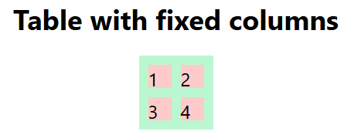
Example 3: Table with varied sized cells using div elements
<div class=" w-fit mx-auto p-6 bg-blue-100">

<!-- Row 1: Two divs with varied width -->
<div class="flex gap-4 mb-4">
<div class="w-1/4 h-24 bg-blue-500 text-white flex items-center justify-center">
Praba
</div>
<div class="w-3/4 h-24 bg-green-500 text-white flex items-center justify-center">
Raghavendrakumar sakali
</div>
</div>

<!-- Row 2: Three divs with varied width -->
<div class="flex gap-4">
<div class="w-0.5/3 h-24 bg-red-500 text-white flex items-center justify-center">
First Quarter
</div>
<div class="w-2/3 h-24 bg-purple-500 text-white flex items-center justify-center">
SSN College of Engineering
</div>
<div class="w-0.5/3 h-24 bg-yellow-500 text-white flex items-center justify-center">
Third Quarter
</div>
</div>
</div>
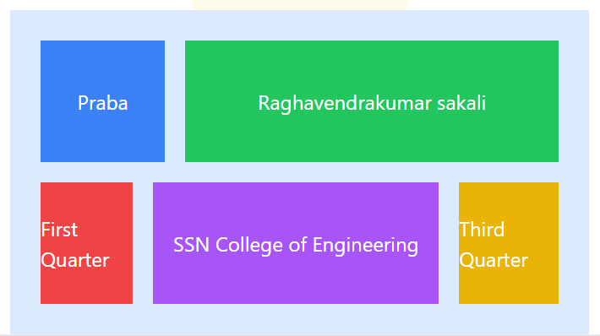

Example 4: Timetable
<div class="mx-auto p-10">
<h2 class="text-2xl font-bold mb-4 text-center">Weekly Timetable</h2>

<div class="grid grid-cols-6 flex mx-auto p-4 bg-red-200 w-fit">

<!-- Header Row -->
<div class="p-4 bg-gray-200 font-bold">Time</div>
<div class="p-4 bg-gray-200 font-bold">Monday</div>
<div class="p-4 bg-gray-200 font-bold">Tuesday</div>
<div class="p-4 bg-gray-200 font-bold">Wednesday</div>
<div class="p-4 bg-gray-200 font-bold">Thursday</div>
<div class="p-4 bg-gray-200 font-bold">Friday</div>

<!-- Row 1 -->
<div class="p-3 border-t border-gray-300">9:00 - 10:00</div>
<div class="p-3 border-t border-gray-300 bg-blue-50">Math</div>
<div class="p-3 border-t border-gray-300 bg-green-50">English</div>
<div class="p-3 border-t border-gray-300 bg-yellow-50">Physics</div>
<div class="p-3 border-t border-gray-300 bg-red-50">Chemistry</div>
<div class="p-3 border-t border-gray-300 bg-purple-50">Biology</div>

<!-- Row 2 -->
<div class="p-3 border-t border-gray-300">10:00 - 11:00</div>
<div class="p-3 border-t border-gray-300 bg-green-50">English</div>
<div class="p-3 border-t border-gray-300 bg-blue-50">Math</div>
<div class="p-3 border-t border-gray-300 bg-red-50">Chemistry</div>
<div class="p-3 border-t border-gray-300 bg-yellow-50">Physics</div>
<div class="p-3 border-t border-gray-300 bg-purple-50">Biology</div>

<!-- Row 3 -->
<div class="p-3 border-t border-gray-300">11:00 - 12:00</div>
<div class="p-3 border-t border-gray-300 bg-yellow-50">Physics</div>
<div class="p-3 border-t border-gray-300 bg-blue-50">Math</div>
<div class="p-3 border-t border-gray-300 bg-purple-50">Biology</div>
<div class="p-3 border-t border-gray-300 bg-green-50">English</div>
<div class="p-3 border-t border-gray-300 bg-red-50">Chemistry</div>

</div>
</div>

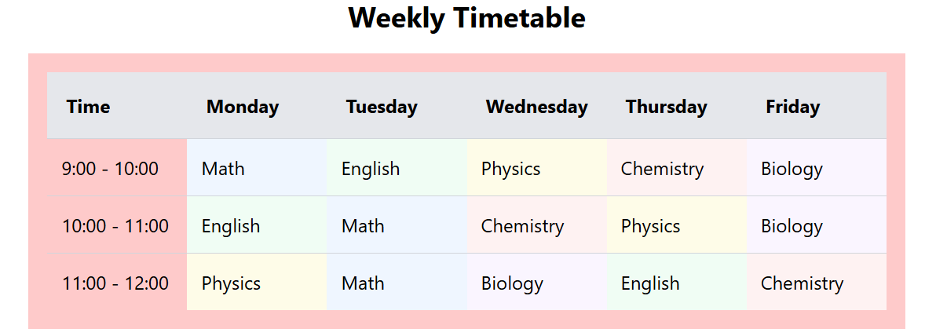
Example 6: Timetable using table with external stylesheet

In ./src/input.css
@tailwind base;
@tailwind components;
@tailwind utilities;
table{
@apply mx-auto;
}
thead{
@apply bg-red-500;
}
th, td {
@apply border border-gray-300;
}
Index. Html
<html>
<head>
<link rel="stylesheet" href="./input.css">
</head>
<body>
<table>
<thead>
<tr><th>Time</th><th>Mon</th><th>Tue</th><th>Wed</th></tr>
</thead>
<tbody>
<tr><th>9-10</th><td>Sci</td><td>Maths</td><td>Soc</td></tr>
<tr><th>10-11</th><td>Soc</td><td>Maths</td><td>Sci</td></tr>
<tr><th>11-12</th><td>Maths</td><td>Sci</td><td>Soc</td></tr>
</tbody>
</table>
</body>
</html>
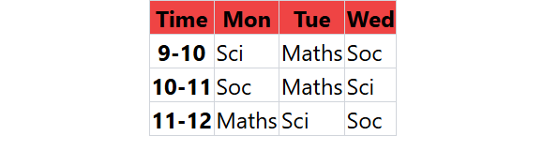
Example 7: FlexBox utility
https://css-tricks.com/snippets/css/a-guide-to-flexbox/
Demonstration of wrap, direction
We can make a container (created using div) as flex – Meaning is as follows:
If the direct children of the flex container is not having space it will wrap the children. We have direction of wrap also

We have breakpoint utility which defines the size of the layout required for different screen sizes (devices). If the children of the container goes beyond the size of the container, flex-wrap can bring the elements into multiple rows

Breakpoints (screen sizes) that wrap utility classes.

Variant | Minimum width | CSS
@3xs | 16rem (256px) | @container (width >= 16rem) { … }
@2xs | 18rem (288px) | @container (width >= 18rem) { … }
@xs | 20rem (320px) | @container (width >= 20rem) { … }
@sm | 24rem (384px) | @container (width >= 24rem) { … }
@md | 28rem (448px) | @container (width >= 28rem) { … }
@lg | 32rem (512px) | @container (width >= 32rem) { … }
@xl | 36rem (576px) | @container (width >= 36rem) { … }
@2xl | 42rem (672px) | @container (width >= 42rem) { … }
@3xl | 48rem (768px) | @container (width >= 48rem) { … }
@4xl | 56rem (896px) | @container (width >= 56rem) { … }
@5xl | 64rem (1024px) | @container (width >= 64rem) { … }
@6xl | 72rem (1152px) | @container (width >= 72rem) { … }
@7xl | 80rem (1280px) | @container (width >= 80rem) { … }

sm- small screen

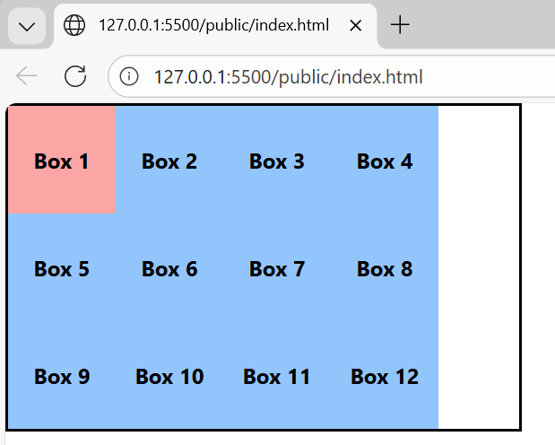

md-medium screen

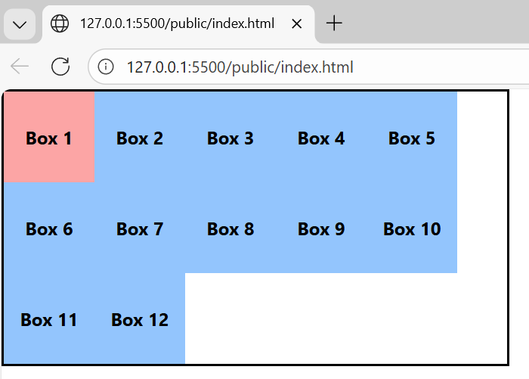

lg-large screen

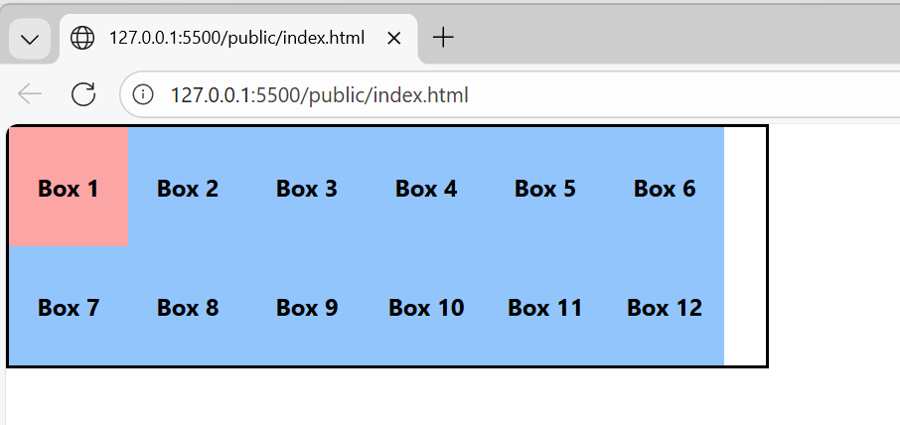

xl-extra large screen

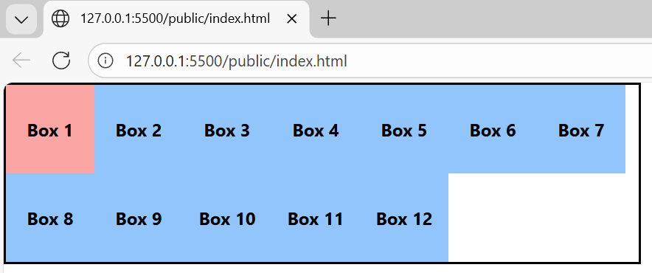

2xl- double extra screen

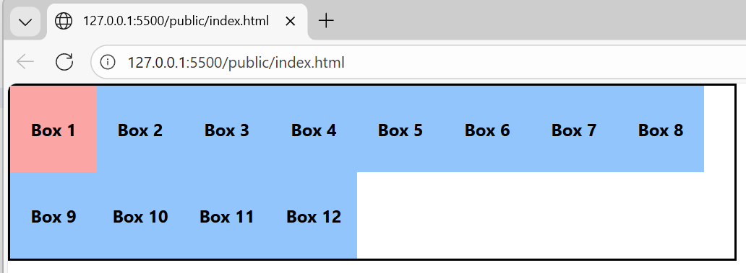

Flex-direction – snapshots

flex-row
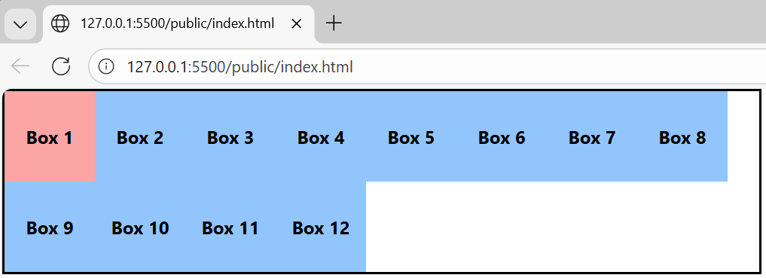

Flex-col
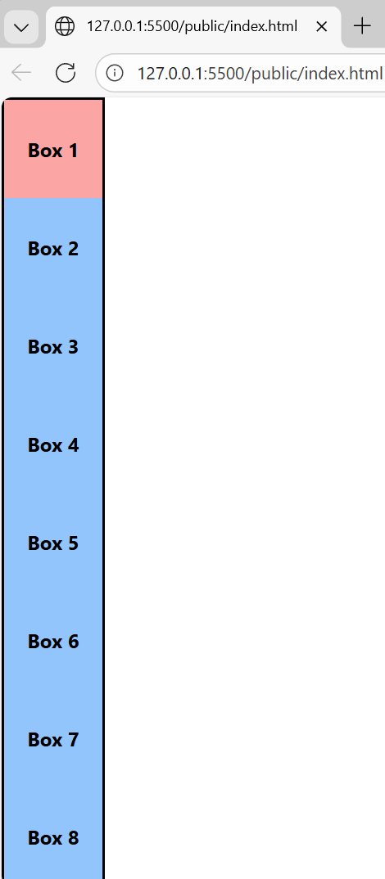

Flex-row-reverse

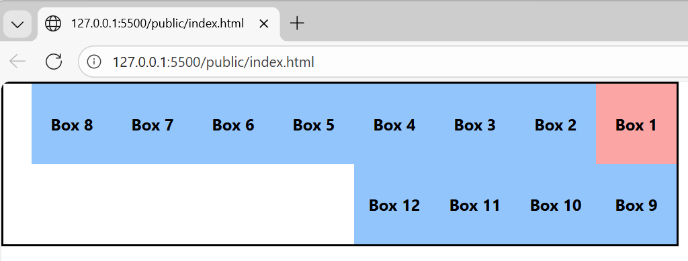

Flex-col-reverse
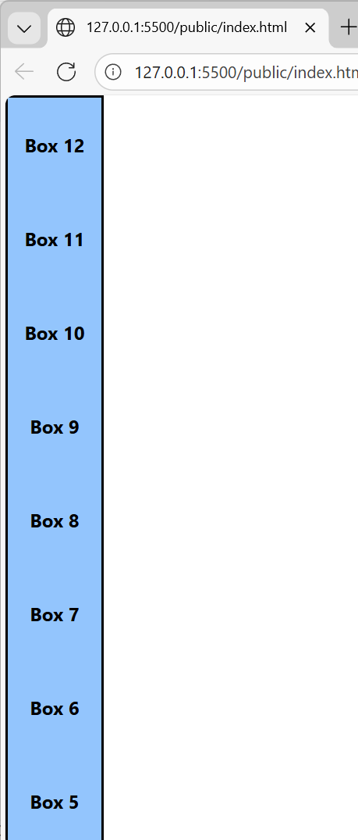

Code:
<html>
<head>
<link rel="stylesheet" href="./input.css">
</head>
<body>
<div class=" w-fit max-w-2xl flex flex-wrap flex-col-reverse border-2 border-black">
<div class="w-20 h-20 bg-red-300 flex items-center justify-center font-bold">Box 1</div>
<div class="w-20 h-20 bg-blue-300 flex items-center justify-center font-bold">Box 2</div>
<div class="w-20 h-20 bg-blue-300 flex items-center justify-center font-bold">Box 3</div>
<div class="w-20 h-20 bg-blue-300 flex items-center justify-center font-bold">Box 4</div>
<div class="w-20 h-20 bg-blue-300 flex items-center justify-center font-bold">Box 5</div>
<div class="w-20 h-20 bg-blue-300 flex items-center justify-center font-bold">Box 6</div>
<div class="w-20 h-20 bg-blue-300 flex items-center justify-center font-bold">Box 7</div>
<div class="w-20 h-20 bg-blue-300 flex items-center justify-center font-bold">Box 8</div>
<div class="w-20 h-20 bg-blue-300 flex items-center justify-center font-bold">Box 9</div>
<div class="w-20 h-20 bg-blue-300 flex items-center justify-center font-bold">Box 10</div>
<div class="w-20 h-20 bg-blue-300 flex items-center justify-center font-bold">Box 11</div>
<div class="w-20 h-20 bg-blue-300 flex items-center justify-center font-bold">Box 12</div>
</div>
</body>
</html>

